Swipe

Game Template

Game documentation and How To guide.

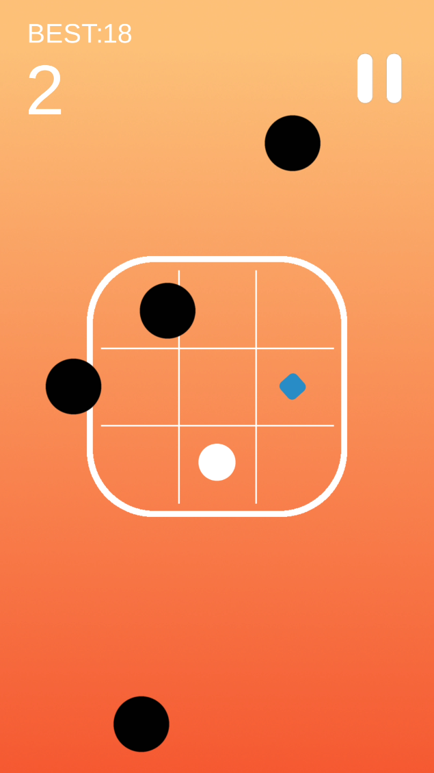

# **Swipe Game is a full Unity template ready for release. It is fun arcade game. It is compatible with mobile (iOS iPhone and iPad, Android, Windows Mobile) standalone (Windows PC and Mac OSX), web player and webGL.**

**How to Play?**

Mobile: Swipe Right, Left, Up, Down to move the player and collect points, but beware of the black Dots.   
Others: use arrow keys to move the player.

**Please rate my file, I’d appreciate it**



Customization Guide

GameController

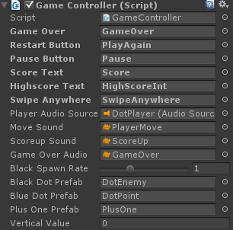

**Game Over:** contains the game over text.

**Restart Button:** contains the Play again button.

**Pause Button:** contains the pause button.

**Score Text:** contains the current score text.

**Highscore Text:** contains the highscore text.

**Swipe Anywhere:** contains the swipe anywhere instruction.

**Player Audio Source:** contains the DotPlayer gameobject which have audio source.

**Move Sound:** contains moving sound.

**ScoreUp Sound:** contains the sound of adding score.

**GameOver Sound:** contains the game over sound.

**Black Spawn Rate:** contains after how many seconds next enemy black dot would instantiate.

**Black Dot Prefab:** contains the DotEnemy gameobject.

**Blue Dot Prefab:** contains the DotPoint gameobject.

**Plus one Prefab:** contains the PlusOne gameobject.

**Vectical value:** Leave it to zero.

For any enquiry contact: **aakarshak51@gmail.com**